Health Campaign Integration Opportunities — Sierra Leone
Planning period 2026–2028 | Prepared for the Campaign Integration Workshop, Kigali | June 2026

Abbreviations
Campaign acronyms used in this report and the workbook, with key technical terms.
Acronym | Definition | Acronym | Definition
MR | Measles–Rubella vaccine (SIA) | TCV | Typhoid Conjugate Vaccine
ITN/LLIN | Insecticide-Treated Net / Long-Lasting Insecticidal Net | SCH | Schistosomiasis preventive chemotherapy
STH | Soil-Transmitted Helminthiases (deworming) | Oncho | Onchocerciasis (CDTI / mass drug administration)
ALB | Albendazole | AZI | Azithromycin
CDD | Community-Directed Distribution / Distributor | CDTI | Community-Directed Treatment with Ivermectin
ESPEN | Expanded Special Project for Elimination of NTDs | Gavi | Gavi, the Vaccine Alliance
IDA | Ivermectin + Diethylcarbamazine + Albendazole | IVM | Ivermectin
MDA | Mass Drug Administration | NTD | Neglected Tropical Disease
PC | Preventive Chemotherapy | PZQ | Praziquantel
SIA | Supplementary Immunization Activity | TEO | Tetracycline Eye Ointment
WHO | World Health Organization

Summary
Sierra Leone's submission covers malaria (ITN/LLIN), preventive chemotherapy for NTDs (schistosomiasis, soil-transmitted helminthiases, onchocerciasis) and immunization SIAs (measles-rubella, typhoid conjugate vaccine) over 2026–2028. The calendar is comparatively spaced, leaving clear scope to cluster interventions that share delivery platforms and target groups.
The strongest co-delivery opportunity is the NTD preventive-chemotherapy package; immunization SIAs offer collaboration gains through shared microplanning.

Integration opportunities (by time and place)
Window | Location | Interventions | Level | Recommended action
2026 · Jul | National | Onchocerciasis + STH | Co-delivery | Co-administer ivermectin + albendazole through the CDD network; add LF where co-endemic
2027–28 · Apr / Sep | All regions | Schistosomiasis (SCH) + STH | Co-delivery | Align to a single school-based round (praziquantel + albendazole) for school-age children
2027 · Mar | National | ITN/LLIN + Measles-Rubella | Collaboration | Shared social mobilisation, transport and microplanning (delivery modes differ)
2027 · Mar & Nov | National | Measles-Rubella + TCV (injectable SIAs) | Collaboration | Shared cold chain, microplanning and teams; consider a combined multi-antigen SIA
Integration ladder: Coordination (shared planning calendar) → Collaboration (shared microplanning, mobilisation, transport, supervision) → Co-delivery (same teams/sites, same window) → Co-administration (products given together to the same person).

Profile-based complementarity
Onchocerciasis (community-directed treatment, ivermectin) and STH (albendazole) share oral administration and overlapping community/school-age targets and are already flagged for joint CDD delivery — the most mature co-administration opportunity. Schistosomiasis (praziquantel, school-age children) shares the school platform with STH; aligning their currently separate windows would allow a single integrated school-based round.
Measles-rubella and TCV are both injectable, delivered through fixed and temporary posts to overlapping child cohorts and supported by Gavi; although planned eight months apart, they can share microplanning, cold chain and social mobilisation, and could be assessed for combined delivery.

Profile-based integration scan
How the score is generated. Every pair of campaigns is scored on two independent axes. Profile fit (0–100) measures operational similarity from the Campaign Characterisation sheet — a weighted match on delivery platform (×2), target population (×2), mode of delivery (×1) and commodity/supply class (×1). Time–place alignment (0–100) is read from the calendar: 100 = same admin-1 unit and same month in a year; 67 = same month, different place; 33 = same year only; 0 = no overlap. The combined integration score = 0.6 × profile fit + 0.4 × time–place, banded into Tier A (≥70), B (50–69), C (30–49) and D (<30).
How to read the figures. Table 2 (final landscape page) lists each campaign's characteristics — a shared cell colour down a column means a shared attribute, so rows sharing colours are integration candidates. The heatmap (Figure 1) gives the integration score for every pair (greener = higher potential). The 2×2 matrix (Figure 2) places each pair by profile fit (x) and time–place alignment (y): top-right = co-deliver now; bottom-right = operationally compatible, reschedule to align; top-left = coordinate logistics only (cannot co-administer); bottom-left = lower priority.

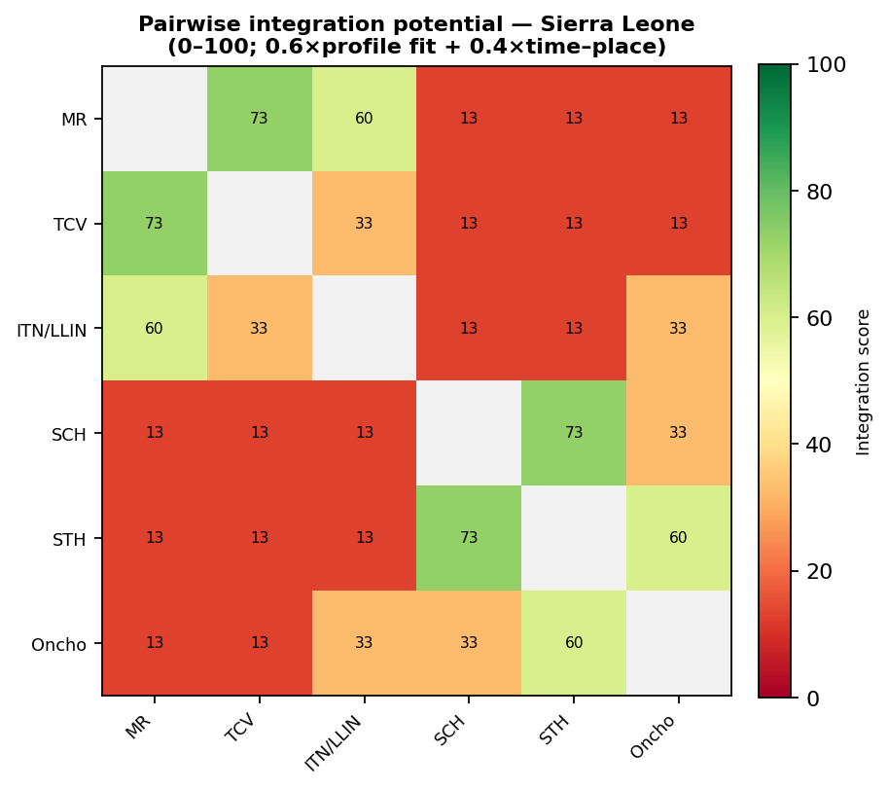
Figure 1. Pairwise integration potential (combined score 0–100).
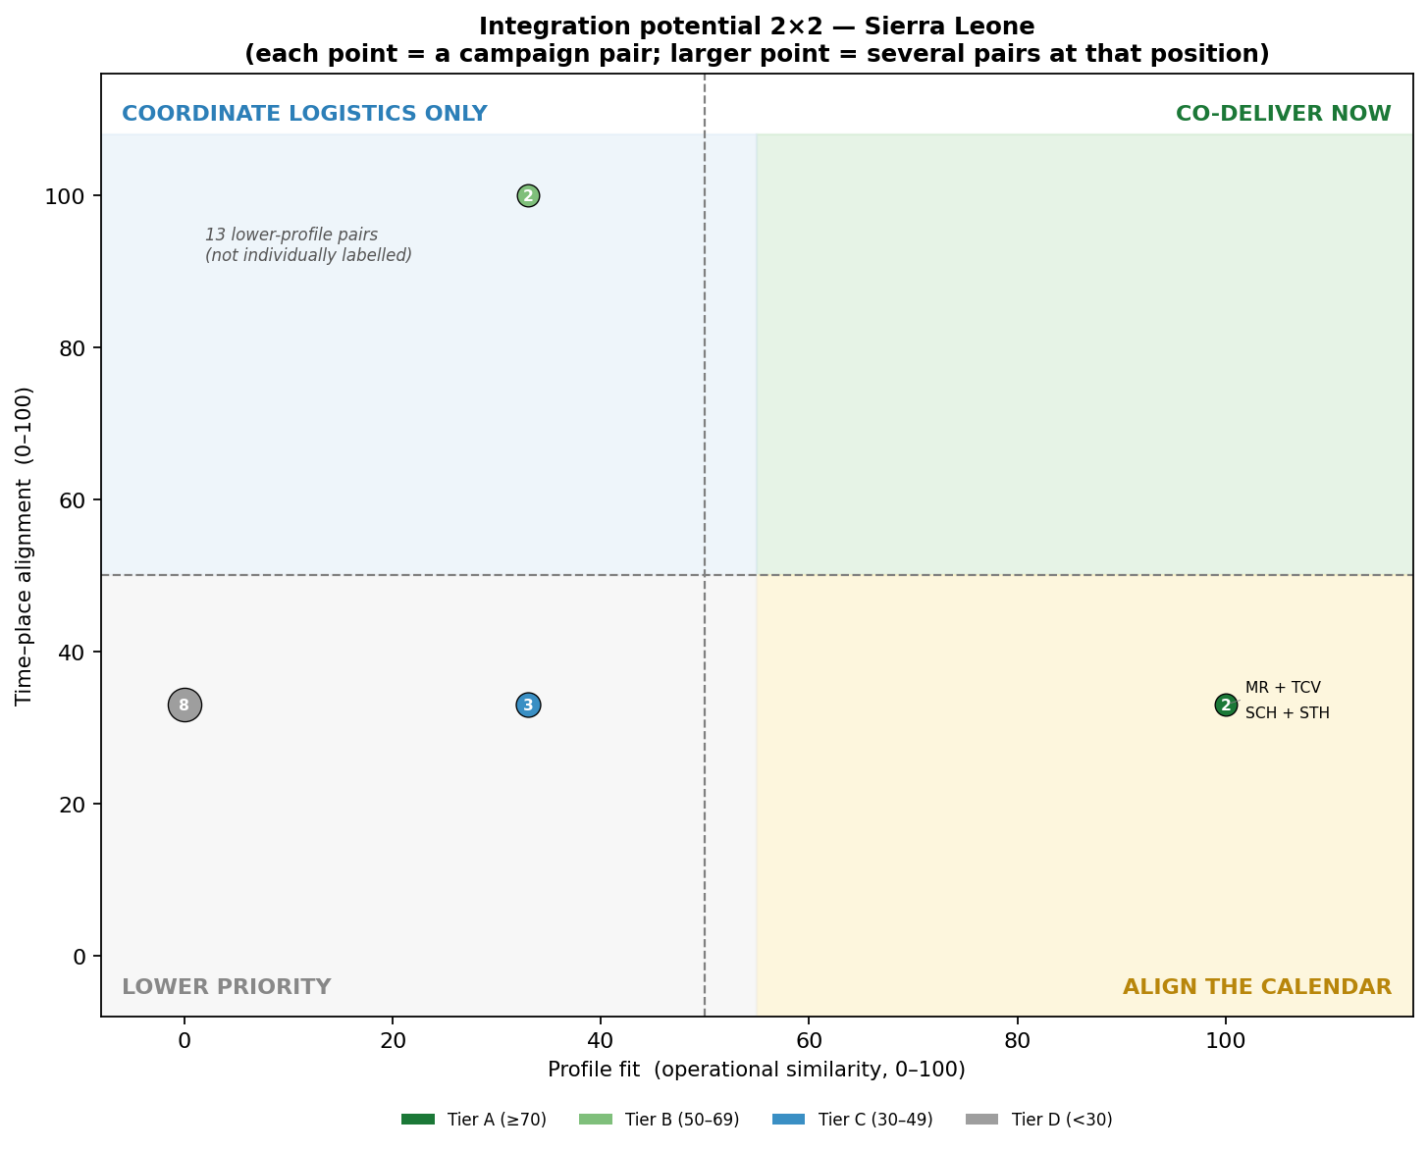
Figure 2. Integration potential 2×2 — each point is a campaign pair, triaged into an action quadrant.

Highest-scoring campaign pairs
Campaign pair | Score | Tier | Shared characteristics | Suggested action
SCH + STH | 73 | A | platform, target group, mode, supply | Align the calendar
MR + TCV | 73 | A | platform, target group, mode, supply | Align the calendar
STH + Oncho | 60 | B | mode, supply | Coordinate logistics
MR + ITN/LLIN | 60 | B | platform | Coordinate logistics
TCV + ITN/LLIN | 33 | C | platform | Lower priority
SCH + Oncho | 33 | C | mode, supply | Lower priority
ITN/LLIN + Oncho | 33 | C | target group | Lower priority
TCV + SCH | 13 | D | none | Lower priority

Recommendations
- Prioritise the NTD-PC co-delivery — deliver onchocerciasis (± LF) and STH together via CDD, and combine SCH + STH in school-based rounds.
- Align immunization SIAs — use shared microplanning and cold chain for MR and TCV; evaluate a single multi-antigen campaign subject to vaccine supply and readiness.
- Exploit calendar coincidence — where ITN and MR fall in the same month (Mar 2027), share mobilisation and transport even though delivery modes differ.
- Confirm endemicity and eligibility — co-administration should follow WHO PC-NTD co-treatment guidance and district endemicity before finalisation.

Annex — Table 2. Campaign characteristics by attribute
Shared colour within a column = shared attribute = co-delivery enabler. ‘+’ = campaign also uses other platforms / target groups.
